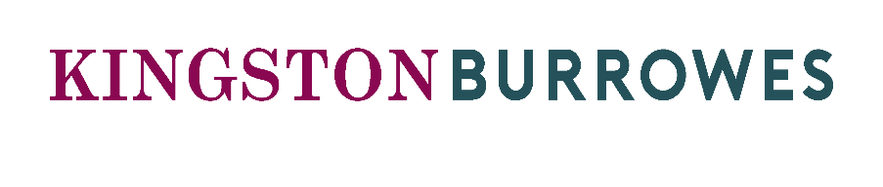
The 2020 Kingston Burrowes Community Fund

We are pleased to confirm that the Kingston Burrowes Community Fund is open again for 2020 applications. Following the success of the initiative over the past two years, we are again inviting local community groups to apply for a share of a £500 fund. Two grants of £250 each will be awarded.
Projects should be focused on work supporting activities with clear benefit to the community, such as working with young people/children, schools, special educational needs, those with disabilities or the elderly. Projects that benefit the local environment such as enhancing the appearance or accessibility of community areas, including events or artistic installations will also be considered.

Those eligible to apply include registered charities, not for profit organisations (including small clubs and societies) or individuals engaged in a specific funding appeal that meets the above criteria.

Your application will need to outline a specific project where the £250 grant will either fund the entire cost of, or comprise a significant contribution to the total required. This could for example include an individual piece of equipment or an event/activity cost. The grants will not be applicable to general running costs or the continuation of existing and ongoing work.

Projects must be located in, and for the benefit of the community in the boroughs of Kingston-upon-Thames or Sutton (where our Surbiton and Cheam offices can be found).

Applications will open on 3rd August 2020 and close at midday on Monday 30th November 2020. Successful grants will be notified within 4 weeks of the closure date.

Please contact amyjudd@kingstonburrowes.com if you have any questions about the application process.

The 2020 Kingston Burrowes Community Fund

Contact Name______________________________________________________
Will the grant be supporting an individual
or organisation*
*Organisation name ___________________________________________________
*Type of organisation __________________________________________________
*Organisation website _________________________________________________
What does the organisation do? (please use no more than 100 words)

Charity number (if relevant) ____________________________________________________
Address for correspondence ____________________________________________________
___________________________________________________________________________
Contact telephone number ____________________________________________________
Contact email address ________________________________________________________
Which Borough will the project take place in?
Kingston-upon-Thames Sutton

Please provide a description of the activities that will be delivered with a grant (please use no more than 100 words)

Who will benefit from the project and how?

Amount requested (max £250)______________
Will the grant fully fund the project? Yes / No
Do you consent to your name and project being used for publicity purposes if your project is a success? Yes / No

---------------------------------------------------------------------------------

Please complete and return the form to: amyjudd@kingstonburrowes.com

